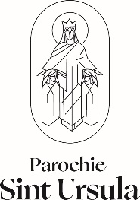

I (and any other family members) would like to be registered in the church community of

O Maria van Jesse O Martha and Maria

O I would like to receive the parish magazine

Additional information for our membership administration

Main resident
Surname *: …………………………………………………………………………………….. O man O woman
* please, give the surname that is registered in jour passport (birthname)

Birth names (in full): ……………………………………………………………………………………………………………………………

Address: …………….………………………………………………………………………………………………………………………………

Postal Code and city: ………………………………………………………………………………………………………………………….

Telephone Number: ……….…………………………………………………………………………………………………………………..

E-mail address: ………………………………………………………………………………………………………………………………….

Date of birth: ………………………… place of birth: …………………………………………… baptised: O yes O no

_O Married O living together O divorced O widow/widower

Partner
Surname *: …………………………………………………………………………………….. O man O woman

Birth names (in full): ……………………………………………………………………………………………………………………………

Date of birth: ………………………….. place of birth: ………………………………………… baptised: O yes O no

Faith (if not RC) ……………………………………………………………………………………………………………………………………

Date marriage \ registered partnership: …………….…………………………………………………………………

Date:……………………………….. Signature: ……………………………………………..

